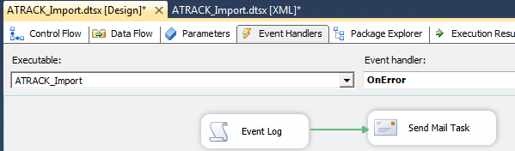

CREATE ERROR_MAIL VARIABLE, TYPE STRING

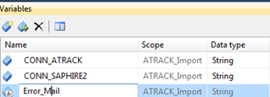

SET ENTRY VARIABLES

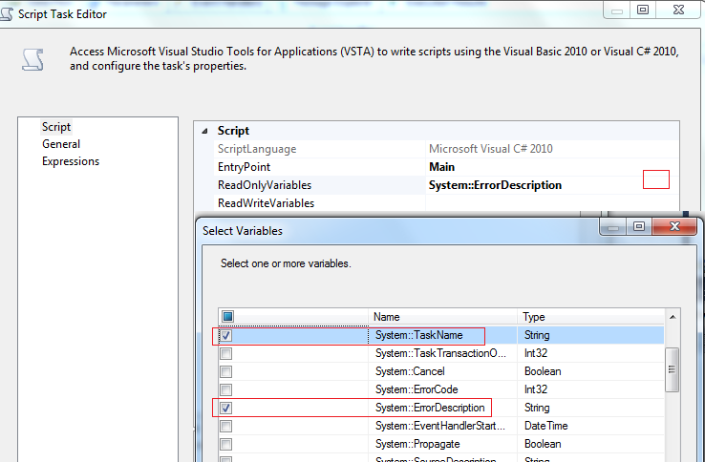

**ReadWiteVariables will be Error_Mail**

string TASK = Dts.Variables["TaskName"].Value.ToString();

string mensaje = TASK + ": "+ Dts.Variables["ErrorDescription"].Value.ToString();

Dts.Variables["Error_Mail"].Value = mensaje;

if (!EventLog.SourceExists("SSIS"))

{

EventLog.CreateEventSource("SSIS","Application");

}

EventLog.WriteEntry("SSIS", mensaje, EventLogEntryType.Warning, 1001, 0);

**CHECKING EVENT_VIEWER**

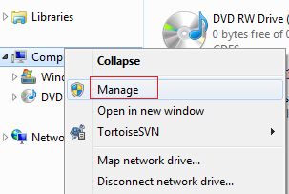

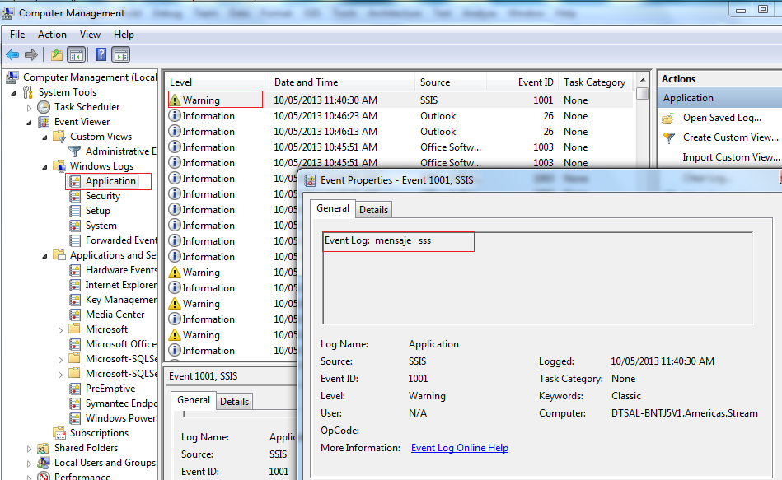

**ERROR IN EMAIL**

In Event Handler



Set email to variable WHICH was set in the script

